End to End mlproject

- Setup the git hub (repository)
- Name : mlproject
- Create folder
- On local system with name : mlproject
- Go inside it and copy the path, here ‘D:\My_Preparation\All Projects\ml project’
- From search tab open anaconda prompt type : cd ‘D:\My_Preparation\All Projects\ml project’
- Type = ‘D:’ & enter
- Type = ‘code .’ & enter (it creates instance of vs code)
- Creating environment
- In vs code, open new terminal, select cmd
- command to create env : ‘conda create -p projenv python==3.8 -y’
- command to activate env : ‘conda activate projenv/’
- command : ‘git init’
- Manually create ‘README.md’ file
- command : ‘git add README.md’
- command : ‘git commit -m ‘’First commit’’ ‘
- command : ‘git status’
- command : ‘git branch -M main’
- command : ‘git remote add origin https://github.com/chinmaykulkarni05/mlproject.git’
- command : ‘git remote -v’
- command : ‘git push -u origin main’
- create manually .gitignore file on github
- In vs code
- create ‘setup.py’ (it is responsible for creating ml application as a package)
- create ‘requirements.txt’
- create src folder and __init__.py inside it
- command : ‘pip install -r requirements.txt’
- again command : now again ‘git add .’
- again command : ‘git commit -m “setup” ‘
- again command : ‘git push -u origin main’
- again terminal opened and activated env
- Inside src folder :
- create ‘component’ folder , inside it :
- create ‘__init__.py’ in src (this components are nothing but all the modules we are going to create)
- create ‘data_ingestion.py’ inside component (this ingestion file is responsible for reading the data, diving it into training and testing)
- create ‘data_transformation.py’ inside component (this transformation file will do changing categorical to numerical feature, OHE, label encoding etc)
- create ‘model_trainer.py’ inside component (this trainer file will have all training code, different models, performance metrics, etc)
- Inside src folder :
- create ‘pipeline’ folder, inside it:
- create ‘train_pipeline.py’
- create ‘predict_pipeline.py’
- create ‘__init__.py’
- Inside src folder :
- create ‘logger.py’ (used for logging )
- create ‘exception.py’ (used for exception handling)
- create ‘utils.py’ (used for any functionalities that are common and used in entire project)
- Now write code in logger.py & exception.py, u can check logs are getting generated (now, one small code is removed from exception.py which was written)
- Create ‘notebook’ folder:
- Problem statement : This project understands how the student's performance (test scores) is affected by other variables such as Gender, Ethnicity, Parental level of education, Lunch and Test preparation course.
- Inside create ‘data’ folder:
- Inside creare ‘EDA STUDENT PERFORMANCE.ipynb’ & ‘MODEL TRAINING.ipynb’
- Add ‘scikit-learn, catboost, xgboost’ to requirements.txt and run it in terminal pip install -r requirements.txt
- Add, commit and push to github
- Inside src, inside components, create ‘data_ingestion.py’ (aim : to read data from specific data source), here all the output will be stored in ‘artifact’ folder as ‘train.csv’ , ‘test.csv’, ‘raw.csv’, now in cmd run ‘src/components/data_ingestion.py’ and see above folder,files,logs are getting created
- Inside .gitignore under environments add ‘.artifacts’
- Again git add, commit, push
- Inside src, inside components, create ‘data_transformation.py’ (aim : handle categorical, numerical values, create pickle file)
- Inside src, create ‘utils.py’ it will have all the common functionalities that project requires, also add ‘dill’ in requirements.txt and run ‘pip install -r requirements.txt’
- Again git add, commit, push
- Inside src, inside components, create ‘model_trainer.py’ (aim : train different models, get their accuracy)
- Again git add, commit, push
- Hyperparameter tuning : just add params {---} code inside ‘model_trainer.py’ and below it in model report add this ‘params=params’, in utils in evaluate_model also add ‘params’
- Again git add, commit, push
- In ml project folder create ‘app.py’, ‘templates’ folder , ‘index.html’ and ‘home.html’
- Inside src, inside pipeline folder create ‘predict_pipeline.py’
- Run ‘python app.py’, open browser type ‘127.0.0.1:5000/‘ you can see home page, if typed ‘127.0.0.1:5000/predictdata’ you can see other page
- Again git add, commit, push
- AWS Deployment begins
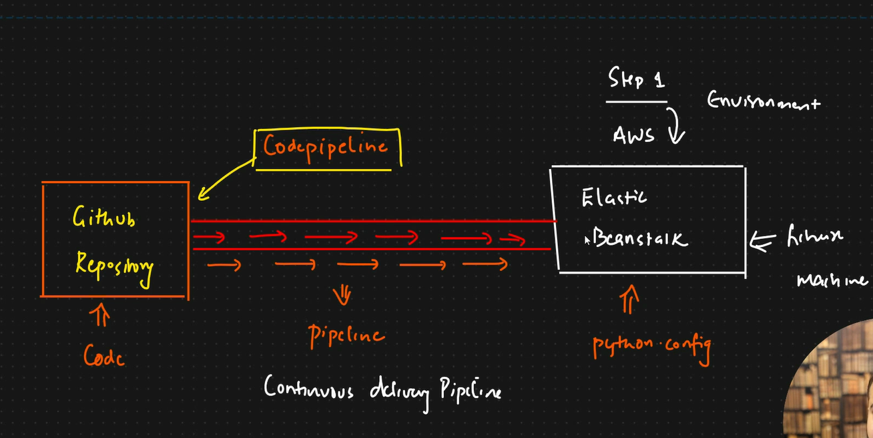
- For AWS Elastic beanstalk, we need to setup two configurations in our project
In ml project create a folder ‘.ebextensions’ & inside it create file ‘python.config’ (file aim : to tell beanstalk instance what is entry point of the application), just for deployment purpose create a copy of app.py and name it as ‘application.py’ & remove debug=True
- Again git add, commit (Deployment configuration for aws), push
- Open and create aws account (what we did CD pipeline)
- In search bar type ‘Elastic Beanstalk’ and click search you will see ‘Elastic Beanstalk(Run and Manage Web Apps)’, in Top features click ‘Applications’
- Click create application ,
- set Application name = StudentPerformance
- platform = python, platform branch = python 3.8 running on 64bit Amazon linux 2, platform version = 3.5.0 (recommended)
- set application code = sample application
- click create application (wait till its created completely)
- open home page In search bar type ‘codepipeline’ and click search you will see ‘codepipeline(release software using continuous delivery)’
- click create pipeline
- set pipeline name = studentperformance
- service role = New Service role (don’t change anything else)
- click on next
- source provider = GitHub (version 1)
- click connect to github, click confirm
- Repository = mlproject
- Branch = main
- Change detection options = GitHub webhooks (recommended)
- Click next
- Build provider = (skip build stage), click next
- Deploy provider = AWS Elastic Beanstalk
- Region = US East (N . Virginia)
- Application name = studentperformance
- Environment name = Studentperformance-env
- click on next
- click on create pipeline (wait for success message) (maybe u will get error, so just delete app.py, it will be sorted)
- In Deploy section click on AWS Elastic Beanstalk in blue
- Now click on URL (u can see application is now open)
- Note : if you make any change in github, then on AWS, in your application it will show Release Change option (all changes will happen to deployed app as well)
- Docker Deployment & then deploying that image on aws (what we did : CI and CD both pipeline )
- Inside mlproject create ‘Dockerfile’ (aim : Create docker image of above and save It in docker hub) & ‘.dockerignore’
- In project folder open cmd and type ‘docker build -t scorecast-ai .’
- Then ‘docker run -p 5000:5000 scorecast-ai’
- Create new repo ‘AWS-CI-CD-Projects’ , copy all the code of proj their , then upload on github, go to actions > search deploy on amazon ecs, it will give template, add your details and ‘.ymal’ file will be generated and click on commit changes , you can create ‘IAM’ number on aws (check yt and get it)
- Create docker image of above and save It in docker hub
- Then u need to push/save this docker image in ECR on AWS (this ECR is fully managed docker container to store, manage, deploy images)

